**Project Design Phase**

**Solution Architecture**

|  |  |
| --- | --- |
| Date | 27 June 2025 |
| Team ID | LTVIP2025TMID30306 |
| Project Name | EduTutor AI: Personalized Learning with Generative AI and LMS Integration |
| Maximum Marks | 4 Marks |

**Solution Architecture:**

Solution architecture is the strategic process of designing an effective and scalable technology system that addresses key learning challenges faced by students and educators. Its purpose includes:

* Selecting the optimal technology stack to personalize education through AI.
* Mapping out the interactions between modules like student input, AI processing, and LMS integration.
* engine), data services, and external APIs.
* Defining architectural layers and dependencies to guide phased development, deployment, and testing.

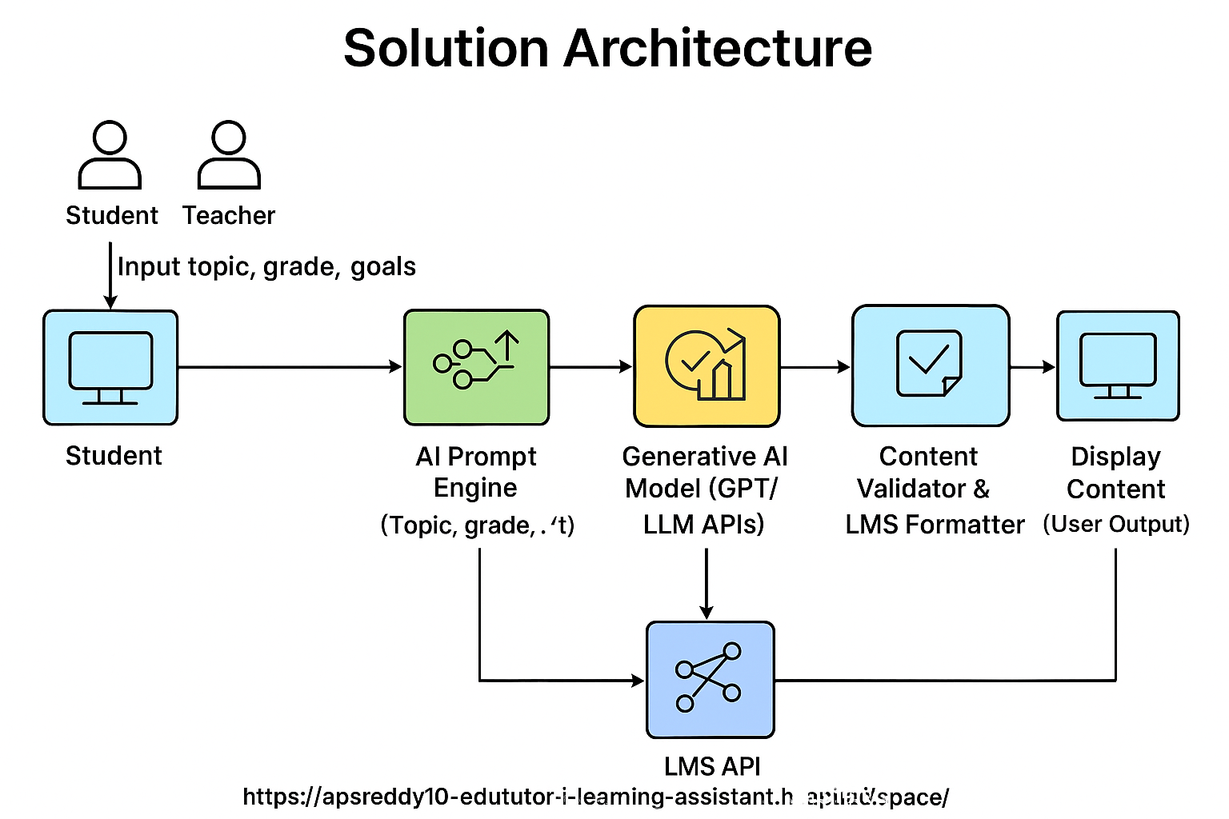

**Example - Solution Architecture Diagram:**

*Figure 1: Architecture and data flow of the edututor-ai-learning-assistant*

**Reference:**[**https://www.eworks.edu.au/newsroom/blogs‑ai‑powered‑lms‑the‑future‑of‑personalised‑learning**](https://www.eworks.edu.au/newsroom/blogsaipoweredlmsthefutureofpersonalisedlearning)